군에 복무하는 사람은 자기를 뽑은 사람에게 충성해야 되기 때문에 사생활에 얽매일 수가 없습니다.
Soldiers don't get tied up in the affairs of civilian life, for then they cannot please the officer who enlisted them.
디모데후서 (2 Timothy) 2:4

Summary of events of service on 12Aug12

Regarding worship
Many people come to believe worship time is a place to sing some songs and listen to some “feel-good” message. I want you to take a different view on what worship is.

Worship is a time where we meet and interact with God. We all live busy lives and things at work, school, or even with friends and family may get hectic. As a result, we lose focus on what we really wish to focus on, that is, to glorify God through our lives. Worship is a chance for us to center back on God.

For example, let’s suppose you had a rough week at work. You don’t want to go back to work, and you really don’t want to see your co-workers or even your boss. Then as we sing songs of Scriptures, such as “all that I am, all that I have, I lay them down before you, Oh Lord” … we remember that the reason why we live is for the Lord. “Father in Heaven how we love you” – we remember that we have a Father who is in control of our situations. He is God even over your difficulties at work, school, relationships. Then we turn our hearts to loving God and consider why we chose to love Him in the first place.

During that time of worship, you can speak with God or allow God to speak Truth over you. It’s a time to interact with God, and let go of yourself. A time to be honest and real before God. It is a time where we can be energized to live again for the Lord. So, worship is for us . . . let’s enter into His presence with thanksgiving and be refreshed whenever we enter into worship. He will meet us there.

Regarding Speaking to Non-Believers
We had a situation where a new member came to ask about how he can become a Christian. Here are some emphases:

- Knowledge-wise
We must be able to share the Gospel with them. We should be able to provide a short version if time is sparse, but generally, we want to be able to walk them through this – perhaps not over one sitting, but over time … particularly while demonstrating Christ’s love with your lifestyle.

The Gospel is simply….

God created man to commune with Him. God provided man with all that he would need and want, and there was satisfaction and happiness in his life. However, sin got in the way, and man could no longer be with God (because God’s holiness does not allow Him to be with sin). We are relational beings, and we also have a longing for us to be close to God as He does for us. For a man to draw close to God, he had to sacrifice animals in his stead to take place of his sins. However, this was not a perfect sacrifice and it was not lasting.

To counteract this, Jesus sent his son to be that perfect sacrifice that would last – this would cover for our past, present, and future sins. Because we are forgiven, we can now draw close to God. In fact, God sent us the Holy Spirit so that He may now dwell in each of us – now we can be very close and intimate with our Creator. He will guide each of us to understand His heart and enable us to live fully and be satisfied and happy as we stay close to listen and follow Him.

- Heart-wise
Our lives should be influential. As we go on sharing our lives with the person to whom we are ministering, we should demonstrate Christ-like character and demonstrate fruits of our following Jesus. Our lives should be attractive and desirable. It is a life-on-life ministry, where we connect our lives (our jobs, businesses, schools, families, etc) in to our faith, and demonstrate that lifestyle to the person seeking to hear.

Readings this week: John 8-14
Carry your Bibles to service next week!

Questions to ask (provide at least two questions to sister Bora Park by Saturday night)
- Something you don’t understand from your reading.
- Question about life, or how you should make a certain decision in your life as a Christian
- Questions about being (or living as) a Christian

Question(s) to ask for this week (again, please submit to sister Bora Park by Saturday night)
- When you were not-yet a believer? What were some questions you really wanted to know before even attempting to know more? What questions, without resolve, were you hindered from knowing God?

Upcoming Events
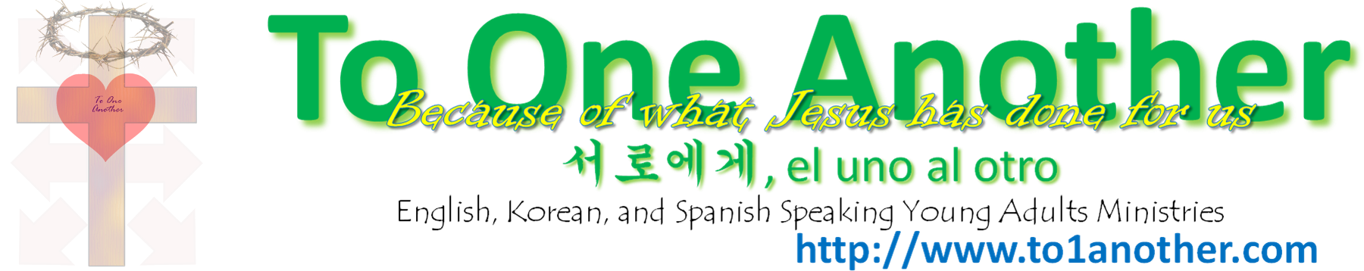
25Aug12 – BBQ at Lake Taghkanic
13Sep12 – Boat Ride in NYC (singles only). More details to come.

